PUBLIC NOTICE
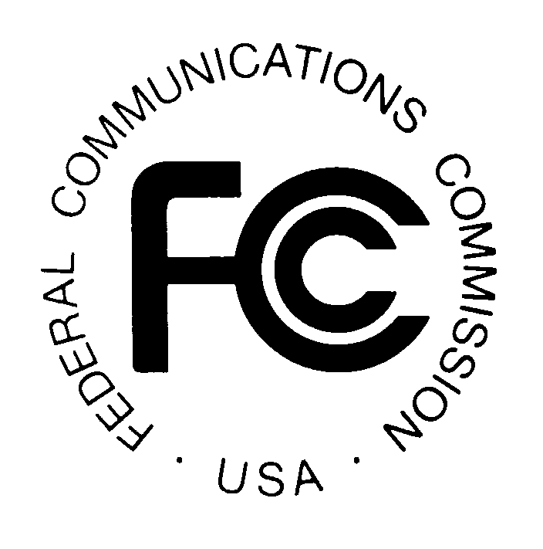
FEDERAL COMMUNICATIONS COMMISSION
445 12th STREET, S.W.
WASHINGTON, D.C. 20554 DA 01-36

News media information 202/418-0500 Fax-On-Demand 202/418-2830 Internet: http://www.fcc.gov ftp.fcc.gov

Released: January 5, 2001

WIRELESS TELECOMMUNICATIONS BUREAU ANNOUNCES AMATEUR SERVICE CLUB AND MILITARY RECREATION STATION CALL SIGN ADMINISTRATORS

On October 21, 1998, the Federal Communications Commission (FCC) adopted a Report and Order reinstituting the use of volunteer organizations for the purpose of processing applications for amateur radio service club, military recreation, and radio amateur civil emergency service (RACES) station licenses. A club station license is an amateur service station license granted only to the trustee of an amateur service club and authorizes the use of a specific call sign. A military recreation station license is an amateur service station license granted only to the person who is the license custodian designated by the official in charge of the United States military recreational premises where the station is situated and also authorizes only the use of a specific call sign. A RACES station license is an amateur service station license granted only to the person who is the license custodian designated by the official responsible for the governmental agency served by that civil defense organization and also authorizes only the use of a specific call sign.

On January 3, 2000, we released a Public Notice announcing that beginning March 1, 2000, we would accept requests from organizations interested in processing applications for amateur service club and military recreation station call signs and that each organization selected would be designated as a Club Station Call Sign Administrator (CSCSA). A CSCSA is an amateur radio organization that has tax-exempt status under Section 501(c)(3) of the Internal Revenue Code of 1986 and that has agreed to provide voluntary, uncompensated and unreimbursed services for processing applications for club, military recreation and RACES station licenses. It has agreed to submit applications to the FCC in an electronic batch file, to retain the application information for at least 15 months, and to make the application information available to the FCC upon request. The CSCSA may collect all necessary information in any manner of its choosing, including creating its own forms.

In response to the January 3, 2000 Public Notice, we received requests from three amateur radio organizations asking to be designated as a CSCSA. These three entities have successfully completed a pilot autogrant batch filing project. Thus, consistent with the procedures outlined in the January 3, 2000, Public Notice, by this Public Notice, we announce the designation of these three entities as CSCSAs.

Beginning January 22, 2001, the FCC will accept applications for new, modification of, or renewal of amateur service club and military recreation station licenses only from a CSCSA. To obtain a new amateur service club station or military recreation station license, to modify or renew an amateur service club station or military recreation station license, or to modify a RACES station license, you must file your application document with one of the CSCSAs. The organizations listed below are CSCSAs and are authorized to file electronically applications for these purposes with the FCC. The CSCSAs are

American Radio Relay League, Inc., 225 Main Street, Newington, CT 06111. Contact: Wayne Irwin (860) 594-0200; world wide web: www.arrl.org; e-mail: clubcalls@arrl.org .

W4VEC Volunteer Examiners Club of America, 3504 Stonehurst Place, High Point, NC 27265. Contact: Jim Williamson (336) 841-7576; world wide web: www.w4vec.com; e-mail: w4vec@aol.com.

W5YI-VEC, P.O. Box 565101, Dallas, TX 75356-5101. Contact: Larry Pollock (817) 461-6443; world wide web: www.w5yi.org; e-mail: NB5X@w5yi.org .

For further information, contact William T. Cross of the Policy and Rules Branch, Public Safety and Private Wireless Division, Wireless Telecommunications Bureau at (202) 418-0680, TTY (202) 418-7233.

By the Chief, Public Safety and Private Wireless Division, Wireless Telecommunications Bureau.

- FCC –

See Biennial Regulatory Review -- Amendment of Parts 0, 1, 13, 22, 24, 26, 27, 80, 87, 90, 95, 97, and 101 of the Commission's Rules to Facilitate the Development and Use of the Universal Licensing System in the Wireless Telecommunications Services, Report and Order, WT Docket 98-20, 13 FCC Rcd 21027, 21105-06 ¶ 181 (1998), on recon., Memorandum Opinion and Order on Reconsideration, 14 FCC Rcd 11476 (1999). No new RACES station licenses will be issued and a RACES station license will not be renewed. See 47 C.F.R. §§ 97.17(a), 97.21(a)(3)(iii).
See 47 C.F.R. § 97.5(b)(2).
See 47 C.F.R. § 97.5(b)(3).
See 47 C.F.R. § 97.5(b)(4).
See FCC Begins Accepting Applications for Amateur Service Club and Military Recreation Station Call Sign Administrators, Public Notice, DA 99-3018 (WTB rel. Jan. 3, 2000).
See Letter dated March 1, 2000, from The American Radio Relay League, Inc.; Letter dated March 1, 2000, from W4VEC, Volunteer Examiners Club of America; Letter dated March 17, 2000, from W5YI-VEC, Inc.

