PUBLIC NOTICE
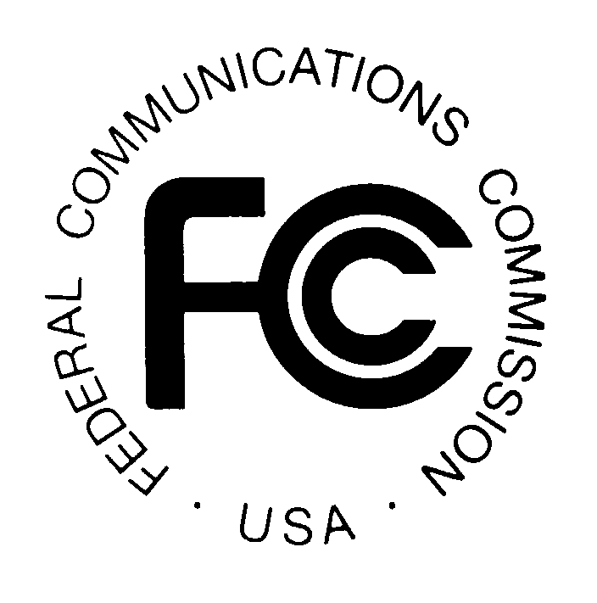

FEDERAL COMMUNICATIONS COMMISSION News Media Information: (202) 418-0500
445 12th STREET, S.W. Fax-On-Demand: (202) 418-2830

WASHINGTON, D.C. 20554 Internet: http://www.fcc.gov

ftp.fcc.gov

DA 00-2257
October 05, 2000

CLOSED BROADCAST AUCTION WINNING BIDDER APPLICATION FOR PAHRUMP, NEVADA ACCEPTED FOR FILING

AUCTION NO. 27

Pleading Cycle Established

The FCC Form 301 long-form application for the winning bidder in Closed Broadcast Auction No. 27 for a FM broadcast construction permit in Pahrump, Nevada listed in Attachment A has been found acceptable for filing. Petitions to deny the application must be filed no later than October 16, 2000, which is ten (10) days from issuance of this Public Notice. See 47 C.F.R. § § 1.4 and 73.5006(b). Opposition and reply pleadings must be filed in accordance with 47 C.F.R. §§ 1.4 and 73.5006(c). Pleadings filed concerning the Closed Broadcast Auction No. 27 application should reference the specific file number of the application.

An original and four copies of all pleadings must be filed with the Commission’s Secretary, Magalie Roman Salas, Office of the Secretary, Federal Communications Commission, 445 Twelfth Street, S.W. Room TW-A325, Washington, D.C. 20054, in accordance with 47 C.F.R. § 1.51(c). In addition, it is requested that a courtesy copy of all pleadings be delivered to James Crutchfield, Audio Services Division, Mass Media Bureau, 445 Twelfth Street, S.W. 2-B450, Washington, D.C. 20554.

After the pleading cycle, the Mass Media Bureau will release a public notice announcing that it is prepared to grant the application. The winning bidder will be required to pay the balance of its winning bid in a lump sum payment within ten (10) business days following the release of that public notice. A construction permit will be awarded upon the full and timely payment of the winning bid and any applicable late fee. See 47 C.F.R. § 73.5003(c).

For further information, contact Lisa Scanlan or James Crutchfield of the Audio Services Division at (202) 418-2700 or Kenneth Burnley, Legal Branch, Auctions and Industry Analysis Division, Wireless Telecommunications Bureau, at (202) 418-0660.

This Public Notice includes an Attachment A.

