PUBLIC NOTICE
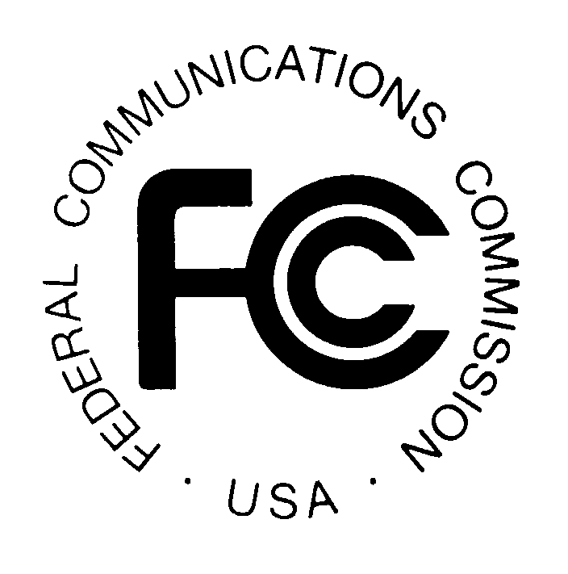

FEDERAL COMMUNICATIONS COMMISSION News Media Information: (202) 418-0500
445 12th STREET, S.W. Fax-On-Demand: (202) 418-2830

WASHINGTON, D.C. 20554 Internet: http://www.fcc.gov

ftp.fcc.gov

DA 99-2731
December 6, 1999

929 and 931 MHz Paging

Pre-Auction Seminar

FRIDAY, JANUARY 7, 2000
The pre-auction seminar for the 929 and 931 MHz Paging Auction is scheduled for Friday, January 7, 2000, with registration beginning at 8:30 a.m., and the seminar ending at 4 p.m. The seminar will be held at the Federal Communications Commission, 445 12th Street S.W., Washington, D.C. Potential bidders in the auction are strongly encouraged to attend. This seminar provides an opportunity for hands-on demonstrations of the FCC filing and bidding software and access to the FCC staff responsible for the Paging service licensing and auction conduct procedures.

The following is a timeline of the important events prior to the auction start date:

Deadline to register for Pre-Auction Seminar: January 5, 2000
Seminar Date: January 7, 2000
Short Form Application (FCC Form 175): January 20, 2000 5:30 p.m. ET
Upfront Payments (via wire transfer): February 7, 2000 6:00 p.m. ET
Orders for Remote Bidding Software: February 8, 2000 5:30 p.m. ET
Mock Auction: February 22, 2000
Auction Start Date: February 24, 2000

It is strongly advised that all potential bidders review the public notices released for the auction and the bidder information package prior to the seminar. To receive a bidder information package, please call 1-888-CALL-FCC, (Press Option #2) or directly at (717)
338-2888.

For further information, please contact Lisa Hartigan of the Wireless Telecommunication Bureau, Auctions and Industry Analysis Division, at (202) 418-0660 or for Press Inquiries, Meribeth McCarrick at (202) 418-0654.

FCC AUCTION SEMINAR REGISTRATION FORM 929 and 931 MHz Paging Auction
The FCC will sponsor a one day seminar for the Paging auction applicants. The seminar is free of charge and will provide information about pre-auction procedures, service and auction rules, conduct of the auction, and the FCC remote bidding software.

Space is limited. A maximum of two representatives from each company may attend on a reservation basis, first-come first-served until room capacity is filled. Additional seating may be available on a stand-by basis the day of the seminar. The seminar will be held:

Friday, January 7, 2000
Federal Communications Commission
445 12th Street S.W.

Washington, DC 20554
Registration 8:30 a.m. - 9:30 a.m.
Seminar 9:30 a.m. - 4 p.m.
If hotel accommodations are needed
Please contact 1-888-CALL-FCC (option #2) for a list of hotels in the area
**********************************
To register, complete the form below and
return. to be received no later than
Wednesday, January 5, 2000, by mail or fax to:

FCC Auction 26
Auctions Operations Branch
1270 Fairfield Road
Gettysburg, PA 17325-7245

FAX: 717-338-2850
Phone: 717-338-2888

I/We will attend the 929 and 931 MHz Paging Auction seminar on
Friday, January 7, 2000

Name of attendee: _____________________________________________________

Name of attendee: _____________________________________________________
Company name: ______________________________________________________
Phone: __________________________ Fax: ______________________________

