PUBLIC NOTICE
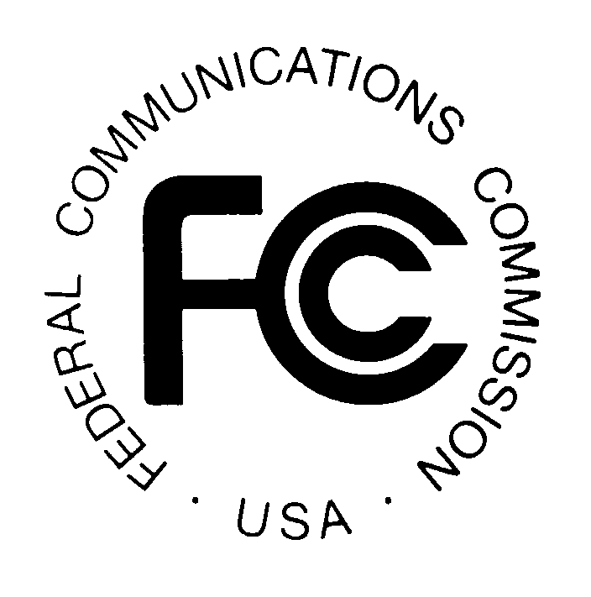

FEDERAL COMMUNICATIONS COMMISSION

445 TWELFTH STREET, S.W.; TW-A325

WASHINGTON, D.C. 20554

News Media Information: (202) 418-0500
Fax-On-Demand: (202) 418-2830
Internet: http://www.fcc.gov
ftp.fcc.gov

DA 01-1347

Released: June 14, 2001

CORRECTION TO
PUBLIC NOTICE DA 01-1347, RELEASED JUNE 5, 2001

FCC ANNOUNCES IT IS PREPARED TO GRANT FM BROADCAST CONSTRUCTION PERMIT FOR BILTMORE FOREST, NORTH CAROLIA AFTER FINAL PAYMENT IS MADE

Balance of Winning Bid due by June 19, 2001

Auction No. 25

By this Public Notice, the Mass Media Bureau, under delegated authority, corrects the
June 5, 2001, Public Notice which announced that the FCC was prepared to grant the subject construction permit. FCC Announces it is Prepared to Grant FM Broadcast Construction Permit for Biltmore Forest, North Carolina After Final Payment is Made, DA 01-1347 (released June 5, 2001) (“June 5, 2001, Public Notice”). The June 5, 2001, Public Notice correctly stated that Liberty Productions, a Limited Partnership (“Liberty”), the winning bidder for Channel 243A at Biltmore Forest, North Carolina (Auction No. 25, FM Market 84), must submit its lump sum final payment within ten business days of the date of the June 5, 2001, Public Notice and may make a late payment within ten business days after the payment deadline, provided that it also pays a late fee equal to five percent of the amount due. However, the specific deadline for submission of Liberty’s lump sum final payment is June 19, 2001. Additionally, Liberty may pay the balance of its winning bid in a lump sum with a late fee equal to five percent of the amount due, by the late payment deadline of July 3, 2001.

All other information provided in the June 5, 2001, Public Notice, including payment instructions, remains in effect.

For questions regarding the calculation and submission of final payment, the FCC Form 159 and refunds, contact Gail Glasser or Tim Dates, Office of the Managing Director, Financial Operations Center, Auctions Accounting Group, at (202) 418-1995.

For questions regarding legal matters and licensing issues, contact Michael Wagner or Jean Ann McGovern, Mass Media Bureau, Audio Services Division at 418-2700.

See 47 C.F.R. §§ 73.5003(c), 1.2109(a).
The June 5, 2001, Public Notice inadvertently reported that the lump sum final payment was due June 15, 2001.
The June 5, 2001, Public Notice inadvertently reported that the late payment deadline was June 25, 2001.

